

Project Title: Development of a Web-Based Business Information and Sales Transaction Management System with QR Code-Based Transaction Tracking for Jaybuilders Industries, Inc.

RESEARCHER
Bansing, Rastel Cyrus R.- BSIT03
Olandria, Gian T. - BSIT-09
Perocho, Tyraelyo L. - BSIT-09
Shimoyama, Jhoshua Chrisitan A. - BSIT-05

November 2026
- Title of the Study
The title reflects the main purpose of the proposed system, which is to develop a web-based platform for organizing business information and managing sales transactions for Jaybuilders Industries, Inc. The inclusion of QR Code-Based Transaction Tracking emphasizes the system’s function of identifying and retrieving recorded transaction information through QR code integration.

- Introduction

In the modern business environment, Information and Communication Technology (ICT) has improved the way companies manage their daily operations and business transactions. Web-based information systems provide businesses with a more organized way to store, access, and monitor important information. By using a centralized platform, companies can reduce difficulties associated with manual record-keeping, improve information management, and support better coordination between departments.
Moreover, proper management of business information and sales transactions is important in maintaining efficient business operations. However, relying on separate spreadsheets, files, and manual records can make it difficult to organize customer information, monitor sales transactions, track transaction progress, and prepare business reports. These challenges may also limit management's ability to review sales activities and identify frequently requested products and services. A centralized system can help address these difficulties by providing authorized employees with a common source of updated business information.
Jaybuilders Industries, Inc. is a construction-related products, fabrication, and services company located in Cagayan de Oro City, Philippines. Based on the client interview, the company has been operating for approximately 40 years, has around 35 employees, and operates from one main location. Its activities involve accounting, production, administration, sales, and customer transactions. The company frequently receives orders for roll-up doors, railings, comfort room (CR) partitions, and metal flush doors, along with other customized products and services. It serves customers through repeat business, existing client relationships, Facebook advertisements, Messenger, other communication channels, and direct visits. Sales personnel handle customer requirements and forward the necessary information to the appropriate department. Currently, the company primarily uses Google Sheets and spreadsheets to maintain business records, while some production tasks and employee assignments are handled manually. Although some production activities already use automated equipment or existing software, the company needs a more centralized way to organize business information, monitor sales transactions, and prepare reports without replacing its established operations or existing accounting software.
This research aims to address these needs by developing a Web-Based Business Information and Sales Transaction Management System with QR Code-Based Transaction Tracking for Jaybuilders Industries, Inc. The proposed system will provide a centralized platform for managing customer information, product and service records, sales transactions, and transaction statuses. It will also provide dashboards and reports to help management review sales summaries and identify frequently requested products and services. In addition, each recorded sales transaction or job order will have a unique QR code that authorized personnel can scan to retrieve its corresponding record based on their assigned access permissions. The system will focus on business information management and sales transaction monitoring rather than replacing the company's existing accounting software or controlling its production operations. Through these features, the proposed system aims to improve the organization, accessibility, and monitoring of business information while supporting the company's existing processes.
- Statement of the problem
Jaybuilders Industries, Inc. uses Google Sheets and spreadsheets to maintain and monitor business information. However, the client identified a need to centralize sales information, improve the visibility of transactions across relevant departments, and obtain summarized business reports more efficiently. The current information management practices may present the following limitations:
- Students may come to the distribution office without prior knowledge whether their materials are available, resulting in unnecessary trips and wait times.
- The staff may experience difficulty in monitoring the availability of the supplies due to inaccurate or insufficient information.
- The distribution of books and modules may become difficult to manage when records of available distributed materials are not properly organized.
- The distribution office may become crowded due to students waiting for their books and modules.
- The absence of an organized system and traditional methods on checking the availability of these materials makes the process more time-consuming for both students and the staff.

Thus, there is a need for a web-based module and book distribution and management system that can assist in organizing learning-material records, monitoring availability and supplies, and management of the distribution of books and modules through QR code integration.
- Objectives of the Study
General Objective
To develop and implement a web-based business information and sales transaction management system that centralizes relevant business records, supports authorized departmental transaction monitoring, and provides summarized sales information for Jaybuilders Industries, Inc.
Specific Objectives
This study specifically aims to:
- To gather and analyze information about the company’s existing business processes, information management practices, and system requirements through interviews and process review.
- To design a web-based system architecture, database structure, user interface, and role-based access model based on the company’s confirmed workflow.
- To develop customer, product, service, and sales transaction management functions that support both standard and customized customer requirements.
- To implement centralized transaction monitoring that allows authorized personnel from relevant departments to access the information needed for their responsibilities.
- To develop a dashboard and automated reports that present periodic sales summaries and frequently requested products and services.
- To integrate QR code generation and scanning functionality for identifying, retrieving, and monitoring sales transaction and job order records by authorized personnel.
- To evaluate the developed system in terms of functionality, usability, reliability, performance efficiency, and security.

- Significance of the Study
This project may benefit the following stakeholders:
Jaybuilders Industries, Inc. – The system may provide a centralized platform for organizing customer, product, service, and sales transaction information and improving access to summarized business data.
Management and Business Owners – Management may review sales activity, transaction progress, periodic reports, and frequently requested products and services through a centralized dashboard.
Sales Personnel – Sales personnel may maintain organized customer information and record customer requirements and sales transactions in one platform.
Accounting Personnel – Authorized accounting personnel may access relevant sales transaction details and summaries that support existing accounting procedures. The system will not replace the company’s accounting software.
Production Personnel – Production personnel may access relevant customer requirements and transaction details needed for their assigned responsibilities.
Authorized Departmental Personnel – Personnel assigned to process a transaction may use its QR code to retrieve the corresponding record more conveniently and review or update its status when permitted by their assigned role.
Customers – Customers may indirectly benefit from more organized handling and monitoring of their inquiries and transactions.
Future Researchers – The study may serve as a reference for future projects involving business information management, sales transaction monitoring, and web-based reporting systems.
- Scope and Delimitations
- Development of a web-based business information and sales transaction management system for Jaybuilders Industries, Inc., accessible to authorized users through supported web browsers.
- Core features will include customer information management, product and service management, sales transaction recording, transaction status monitoring, and sales reporting.
- The system will support flexible product and service records to accommodate customer-specific requirements beyond the company’s frequently requested products.
- Authorized users from management, sales, accounting, production, and administration will be provided access according to their assigned roles and approved responsibilities.
- The system will provide a dashboard and periodic reports showing sales summaries and frequently requested products and services.
- The system will generate a unique QR code for each recorded sales transaction or job order. Authorized personnel may scan the code to retrieve the linked transaction record and access status-monitoring functions according to their assigned permissions.
- Financial summaries will be limited to available and authorized sales transaction information.
- Optional complaint, cancellation, and warranty records may be included if confirmed during final requirements gathering.

Type of Development – Web-Based System
Type of System – Business Information System, Sales Transaction Management System, and Reporting System
Client – Jaybuilders Industries, Inc., Cagayan de Oro City, Philippines
Development of - Web-Based Business Information and Sales Transaction Management System with QR Code-Based Transaction Tracking for Jaybuilders Industries, Inc.
Delimitation
- The system will be developed for Jaybuilders Industries, Inc. and will initially focus on its identified main operating location.
- The system will not replace the company’s existing accounting software.
- Full accounting operations, bookkeeping, payroll processing, and tax computation will not be included.
- The system will not directly control production machinery, fabrication equipment, or other manufacturing hardware.
- The system will not replace all existing departmental procedures or make business decisions on behalf of management.
- Direct integration with Facebook, Messenger, or other external communication platforms will not be included unless technically feasible and approved by the client.
- Inventory control, purchasing, supplier management, delivery tracking, and full production scheduling will not be included as core functions unless additional requirements are confirmed.
- Features outside the agreed project requirements will not be included in the initial development.
- QR codes will be used for transaction identification and record retrieval only. They will not independently authorize access, serve as proof of payment or product release, or provide direct control of production equipment. Scanning will still require the appropriate system access permissions.

- Methodology
The study will adopt a Developmental Research approach using the Agile methodology for the iterative design, development, testing, and improvement of the proposed system. Agile is appropriate because the company’s detailed transaction workflow, departmental access requirements, and reporting needs will be validated with client representatives throughout development.

3.1 Research Design
This study will use a Developmental Research approach. The researchers will focus on designing and developing a web-based business information and sales transaction management system for Jaybuilders Industries, Inc. The approach is appropriate because the study involves identifying the company’s existing business information practices and developing a system based on its confirmed requirements.

The researchers will identify the company’s current processes for handling customer information, product and service requests, sales transactions, and departmental responsibilities. The information gathered through interviews and process reviews will be analyzed to determine the functional and non-functional requirements of the proposed system. These requirements will guide the design and development of the platform.
3.2 Research Locale
The study will be conducted at Jaybuilders Industries, Inc., located in Cagayan de Oro City, Philippines. The company operates in construction-related products, fabrication, and services and maintains one main operating location. The researchers selected the company as the research locale because the proposed system is intended to organize its business information and support the monitoring of sales transactions across relevant departments.
Information about the company’s existing business processes and information management practices will be gathered to guide the development of the proposed system. The study will focus on the identified main operating location of Jaybuilders Industries, Inc.

3.3 Respondents of the Study
The intended participants will include authorized company representatives and personnel from the relevant stakeholder groups involved in the company’s business information and sales transaction processes. These may include management and business owners, sales personnel, accounting personnel, production personnel, administrative personnel, and other authorized departmental personnel, as applicable to requirements gathering and system evaluation.
The participants will provide information about their assigned responsibilities, the records they maintain or access, the transaction details needed by their departments, and the reports required for their work. Intended users may also provide feedback during system evaluation. No respondent count or individual participant names are specified in the current concept paper.

3.4 Data Gathering Procedure
The researchers will gather the needed information through interviews and process reviews with authorized company representatives. First, the researchers will identify the company’s existing business processes and the way customer information, product and service details, and sales transactions are currently recorded. This will include reviewing the use of Google Sheets and spreadsheets in maintaining business information.
Second, the researchers will gather information about the departments involved in handling customer requirements and sales transactions, the details required by each department, and the manner in which transaction progress is monitored. Third, the researchers will identify the sales summaries and reports needed by management and determine the access requirements of the intended users.
The information gathered will be analyzed and used as the basis for the system requirements, database structure, interface, and role-based access model. The proposed interview questionnaire in Appendix A may guide requirements validation. The researchers will not treat proposed questions as completed interview responses.

3.5 System Development Method
The researchers will use the Agile methodology to guide the iterative development of the proposed system. The system will be developed in increments, allowing requirements and the proposed workflow to be reviewed with client representatives throughout development. The following activities will guide the process:
Requirements Gathering – Interviews and process reviews will be conducted with authorized company representatives to identify current business processes, customer information requirements, transaction details, departmental responsibilities, and reporting needs.
System Analysis – The researchers will identify the functional and non-functional requirements of the system, including data requirements, user roles, access permissions, and transaction monitoring needs. The analysis will establish the information that must be maintained and made available to authorized users.
System Design – The researchers will prepare the use case diagram, entity-relationship diagram, database structure, system architecture, process flows, and user interface prototypes. The design will reflect the company’s confirmed workflow and the proposed system’s customer, product, service, transaction, monitoring, QR code, and reporting functions.
Development – The system will be developed incrementally using Agile iterations. The development will cover customer, product and service, sales transaction, transaction monitoring, and reporting functions, together with the user access model defined by the requirements.
QR Code Integration – A unique QR code will be generated for each recorded sales transaction or job order. The code will reference the corresponding transaction record. Scanning and retrieval will remain restricted by the system’s authentication and role-based access controls; the QR code will not independently authorize access.
Testing – The system will undergo functional testing, integration testing, QR code generation and scanning tests, access-control testing, usability checks, and user acceptance testing. The testing instruments in Appendix F are intended for use during the later development and evaluation phases.
Evaluation – Feedback from intended users and qualified IT evaluators will be used to assess the system in terms of functionality, usability, reliability, performance efficiency, and security. The evaluation will identify areas that may require improvement.

Development Tools
• Frontend: HTML5, CSS3, JavaScript, and Bootstrap
• Backend: PHP with Laravel
• Database: MySQL or MariaDB
• Reporting and Analytics: Chart.js
• Development Environment: Visual Studio Code
• Version Control: Git and GitHub
• Testing: Functional testing tools, browser testing, and user acceptance testing forms
The listed technologies are proposed development tools and are not identified as technologies currently used by Jaybuilders Industries, Inc.

3.6 System Evaluation
The researchers will evaluate the developed system to determine whether it meets the requirements and intended purposes identified in the study. Feedback from intended users and qualified IT evaluators will be considered. The evaluation will focus on the following criteria:
• Functionality – determines whether the system’s functions operate according to the identified requirements, including customer, product and service, sales transaction, transaction monitoring, reporting, QR code, and access-control functions.
• Usability – determines whether intended users can understand and use the system’s interfaces and functions to perform their assigned tasks.
• Reliability – determines whether the system operates consistently and produces the expected results when users perform supported operations.
• Performance Efficiency – assesses the system’s responsiveness and its ability to perform its functions within an acceptable time during use.
• Security – assesses whether authentication and role-based access controls restrict users to the information and functions permitted by their assigned responsibilities.
The functional testing checklist, sample test cases, user acceptance testing questionnaire, and software quality evaluation in Appendix F will serve as instruments for the later testing and evaluation phases. No completed test results or evaluation findings are presented in this proposal.

3.7 Ethical Considerations
The researchers will handle information gathered during interviews and system evaluation responsibly. Information provided by authorized company representatives and intended users will be used for the purposes of the research and system development. Any personal or business information included in the system or research records will be handled with appropriate care and will not be disclosed beyond its authorized use. The researchers will explain the purpose of information gathering to participants before collecting their responses. This subsection describes the intended responsible handling of information and does not represent that interviews, approvals, or evaluation activities have already been completed.

3.8 Summary of the Methodology
The methodology will begin with requirements gathering through interviews and process reviews with authorized company representatives. The researchers will analyze the company’s current business information practices, customer and transaction records, departmental responsibilities, access requirements, and reporting needs. The results will guide the design of the system architecture, database, user interface, and role-based access model.
The proposed system will then be developed incrementally using Agile methodology. Development will cover the customer, product and service, sales transaction, transaction monitoring, reporting, and QR code functions. After development, the system will undergo testing and evaluation based on functionality, usability, reliability, performance efficiency, and security. These activities will guide the development of a system that supports the company’s confirmed business workflow.

- Review of Related Literature
Business information systems support organizations by collecting and organizing operational data for daily activities and decision-making. A centralized database can connect customer, product, service, and transaction records, allowing authorized users to retrieve consistent information. This principle is relevant to Jaybuilders Industries, Inc. because the company currently uses Google Sheets and spreadsheets and has expressed the need to consolidate sales information for easier monitoring and reporting.
Tanaman, Baylosis, Abiles, Catungal, and Encarnacion (2023) presented a web-based inventory management system for a small business in the Philippines. Their study demonstrated how a web-based platform can organize business records and support electronic reporting. The study is related to the proposed project because both involve improving access to business information through a centralized system. However, the proposed Jaybuilders system focuses on customer, product and service, and sales transaction information rather than a full inventory management process.
Juanatas and Juanatas (2024) developed a web- and mobile-based ordering and inventory system with sales analytics. Their work highlights the value of connecting transaction records with sales summaries and visual reports. This is relevant to the proposed system’s reporting functions. The Jaybuilders project will differ by supporting flexible descriptions for customized fabricated products and services based on customer requirements.
Usita, Escultor, Garcia, Manuel, and Guinanao (2025) evaluated a web-based inventory system for food-sector micro, small, and medium enterprises using the Technology Acceptance Model. Their study emphasizes the importance of evaluating user acceptance when introducing a business information system. This supports the inclusion of user feedback and usability evaluation in the proposed Jaybuilders project.
Bhardwaj (2022) reviewed data analytics in small and medium enterprises and discussed factors that influence the adoption and use of analytics. The review is relevant because useful business reports depend on the availability, completeness, and quality of organizational data. For Jaybuilders, the proposed dashboard will focus on practical summaries derived from recorded transactions rather than advanced predictive analytics.
Tsiu, Ngobeni, Mathabela, and Thango (2025) reviewed the applications and competitive advantages of data mining and business intelligence in small and medium enterprises. Their review discusses how dashboards and analytics can support business decision-making while recognizing challenges such as cost, technical complexity, and skills. This supports a practical reporting approach that presents understandable sales summaries and product demand information suited to the company’s requirements.
These studies support the use of centralized web-based information systems, structured business records, and reporting tools. However, the proposed project is tailored to Jaybuilders Industries, Inc. by combining customer information, flexible product and service records, sales transaction monitoring, authorized departmental access, and management-oriented sales reports in one platform. The system will be designed around the company’s confirmed workflow and will retain the role of its existing accounting software.

- Expected Output
The final output will be a functional web-based business information and sales transaction management system for Jaybuilders Industries, Inc. with the following deliverables:
- Centralized customer information management module.
- Product and service management module that supports standard and customized customer requirements.
- Sales transaction management module for recording customer requirements, requested products and services, and transaction details.
- Transaction monitoring interface for authorized personnel from relevant departments.
- QR Code-Based Transaction Tracking feature for generating transaction-specific QR codes and retrieving linked records through authorized scanning.
- Management dashboard showing summarized sales activity and frequently requested products and services.
- Periodic sales reports and limited financial summaries based on available and authorized transaction data.
- Role-based user access and relevant system documentation.

The proposed system is expected to address the identified need for centralized business information, improve the visibility of sales transactions, and make summarized sales information easier to review. Actual improvements in productivity or business performance will be determined only after implementation and evaluation.

- References
Bhardwaj, S. (2022). Data analytics in small and medium enterprises (SME): A systematic review and future research directions. Information Resources Management Journal, 35(2), 1–18. https://doi.org/10.4018/IRMJ.291691
Juanatas, R. A., & Juanatas, I. C. (2024). A web and mobile-based ordering and inventory system with sales analytics. In Proceedings of the 2024 15th International Conference on E-Education, E-Business, E-Management and E-Learning (pp. 362–367). Association for Computing Machinery. https://doi.org/10.1145/3670013.3670077
Tanaman, M. T., Baylosis, J. L. A., Abiles, B. J., Catungal, M. L., & Encarnacion, P. C. (2023). Web-based inventory management system. International Journal of Science and Applied Information Technology, 12(5), 44–48. https://doi.org/10.30534/ijsait/2023/021252023
Tsiu, S. V., Ngobeni, M., Mathabela, L., & Thango, B. (2025). Applications and competitive advantages of data mining and business intelligence in SMEs performance: A systematic review. Businesses, 5(2), 22. https://doi.org/10.3390/businesses5020022
Usita, M. M., Escultor, M. D., Garcia, A. B., Manuel, A. R., & Guinanao, G. O. (2025). Evaluating the acceptance of iProSES: A web based inventory system for food sector MSMEs using the Technology Acceptance Model (TAM). Asian Journal of Economics, Business and Accounting, 25(7), 43–54. https://doi.org/10.9734/ajeba/2025/v25i71874

- Appendices
Appendix A – Consolidated Data

A.1 Organization Background and Interview Information
Jaybuilders Industries, Inc. is located in Cagayan de Oro City and operates in construction-related products, fabrication, and services. The company has approximately 35 employees and has been operating for approximately 40 years, based on the information provided for the study.
The company operates from one main location and has personnel involved in accounting, production, administration, sales, and customer transactions. Business information is currently maintained and monitored through tools that include Google Sheets and other spreadsheets. The company also has existing accounting software.
Frequently requested products include roll-up doors, railings, CR partitions, and metal flush doors. Other products and services are accommodated according to customer requirements.

A.2 Interview Guide (Management and Company Personnel)
The following questions are proposed for requirements gathering and validation with authorized company representatives and personnel. They are intended to clarify the existing business process and the information required by the proposed system.
- How does the company currently receive and record customer inquiries and requests for products or services?
- What customer information is collected when a customer makes an inquiry or places an order?
- How are customer details and sales transactions currently recorded and updated?
- Which departments need access to customer information and sales transaction details?
- How is the progress or status of a customer transaction currently monitored?
- What information do sales personnel need to record when preparing a sales transaction or job order?
- What product and service details should be maintained, including customized customer requirements?
- What transaction information is needed by accounting and production personnel to perform their responsibilities?
- What sales reports, summaries, or dashboard information does management regularly need?
- What accounting software is currently used, and does it support an approved export or integration method?
- What user roles and access permissions should be provided for management, sales, accounting, production, administration, and system administration?
- What improvements do you expect from a centralized business information and sales transaction management system with QR code-based transaction tracking?

A.3 Survey Questionnaire (Company Personnel)
Instructions: Please rate each statement based on your experience with the company’s current process of handling customer information, sales transactions, and transaction monitoring.
Scale:
1 – Strongly Disagree
2 – Disagree
3 – Neutral
4 – Agree
5 – Strongly Agree
- Customer information is easy to locate when needed.
- Customer and sales transaction records are properly organized.
- The current process makes it easy to monitor the progress of customer transactions.
- Relevant transaction information is communicated to the departments that need it.
- It is easy to retrieve the product and service details required for customer transactions.
- The current process provides management with the sales information needed for decision-making.
- Manual or spreadsheet-based recordkeeping can result in duplicated, incomplete, or inconsistent information.
- A centralized web-based system would make customer and transaction information easier to manage.
- QR code-based transaction tracking would make it easier for authorized personnel to retrieve transaction records.
- I believe the proposed system can improve the organization and monitoring of sales transactions.

Appendix B – Use Case Diagram

Management – Views the dashboard, monitors overall sales transactions, and generates business reports. They use the system to review business performance and track sales activities. The information helps them make better business decisions and identify frequently requested products and services.
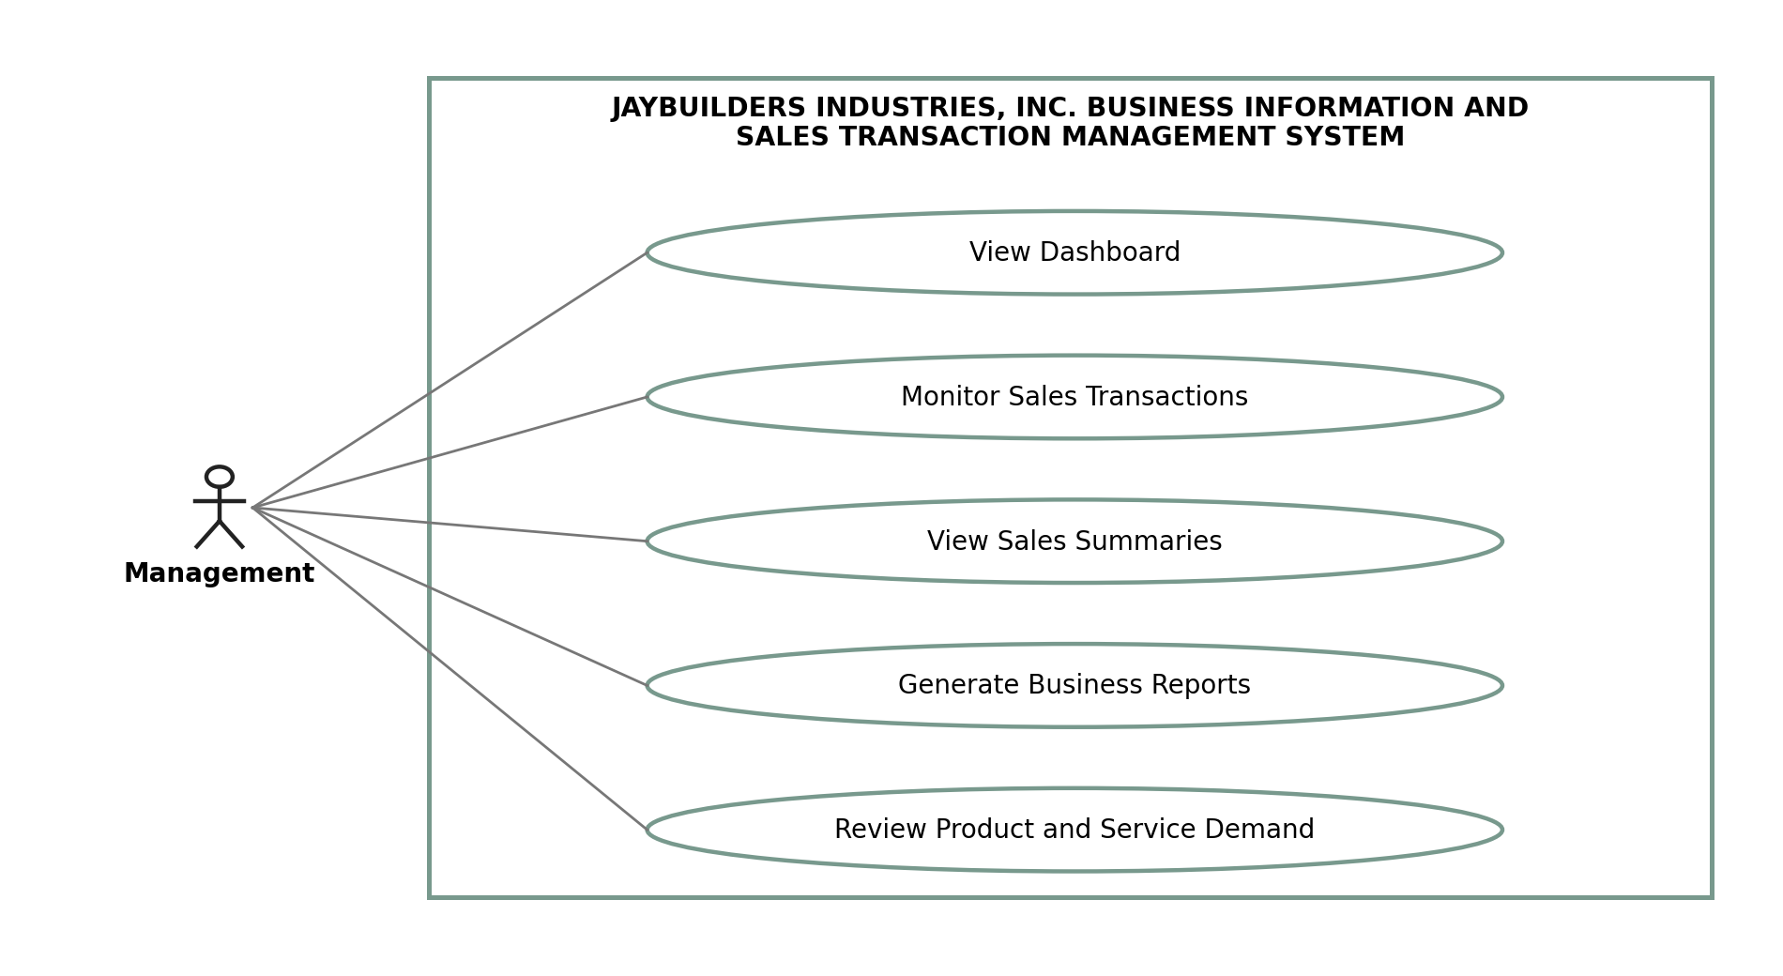
Sales Personnel – Manages customer information, records customer requirements, and creates sales transactions or job orders. They keep customer and sales records updated and generate QR codes for recorded transactions.
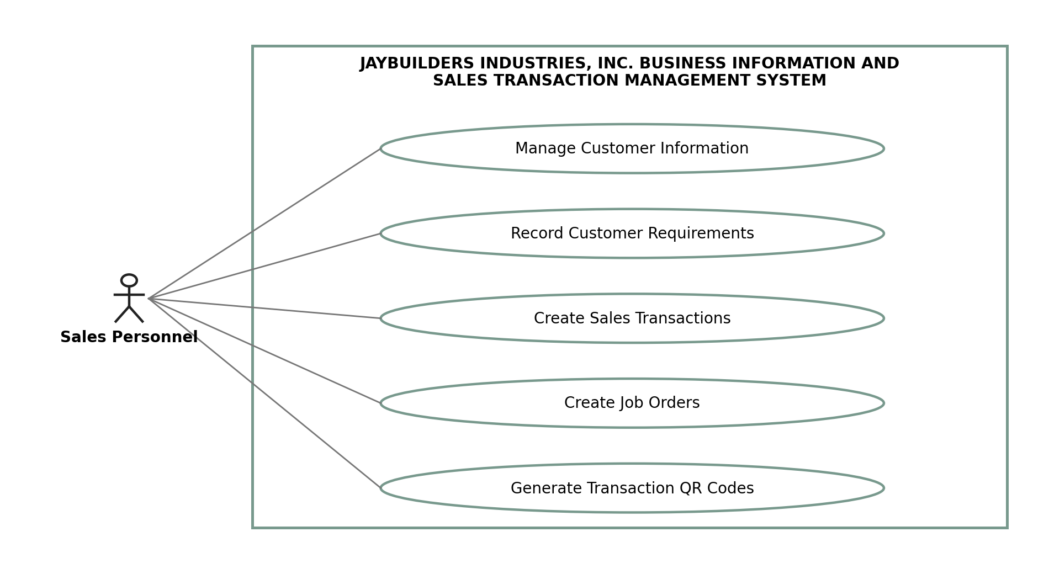
Accounting Personnel – Views sales transaction details and sales-related financial summaries. They use the system to review authorized sales records and access organized transaction information for accounting purposes.
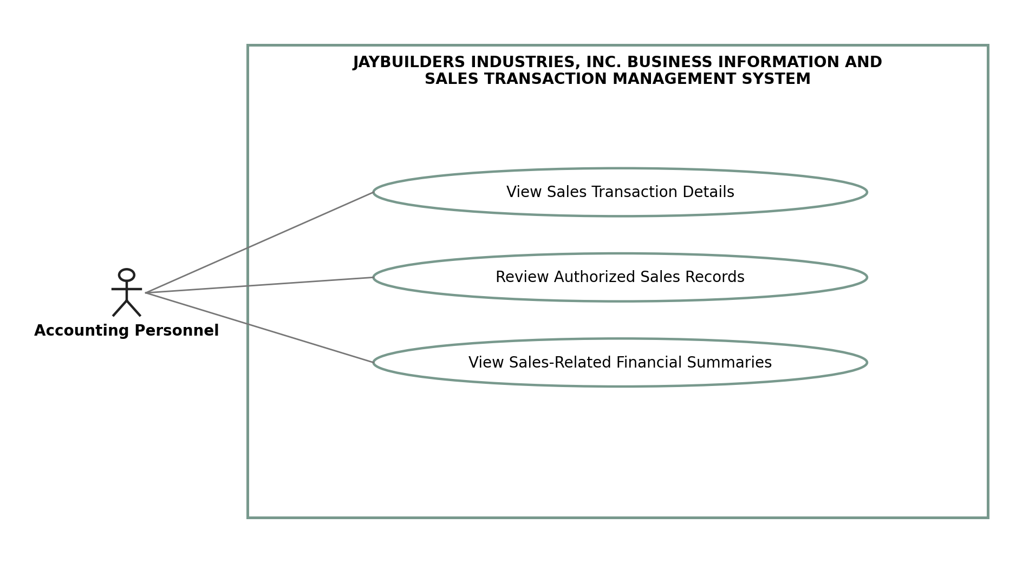
Production Personnel – Views customer requirements and job order details. They can scan QR codes to retrieve transaction records and update the status of assigned jobs.
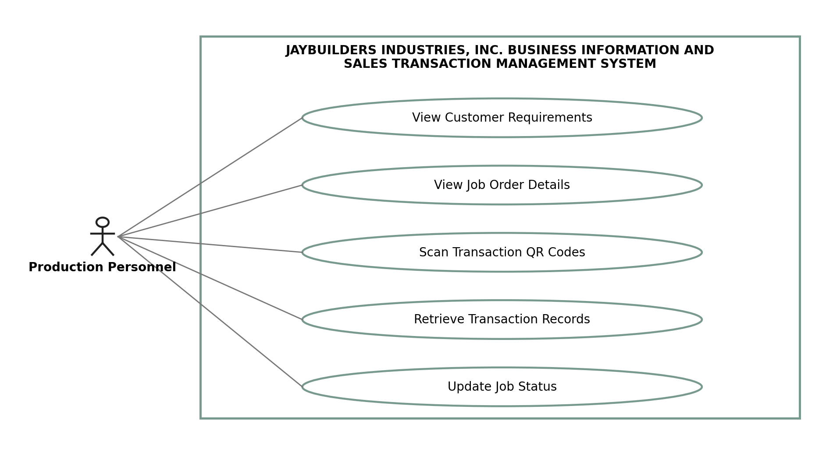
Administrative Personnel – Accesses relevant customer information and transaction records for administrative tasks. They can scan QR codes to retrieve details and update transaction statuses based on their assigned permissions.

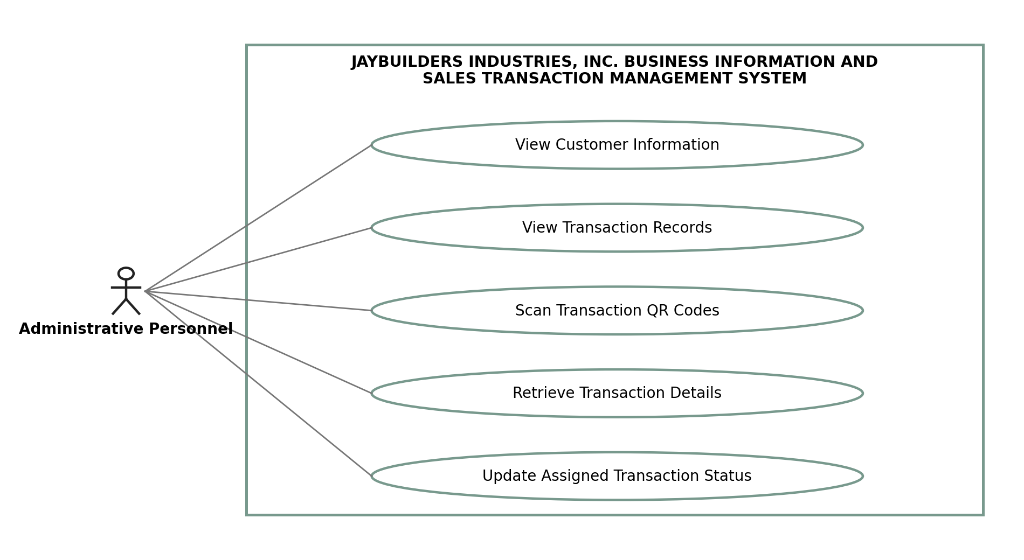 Administrator – Manages user accounts, assigns user roles, and controls system access permissions. They maintain user access and help ensure that each user can only access the functions allowed for their role.
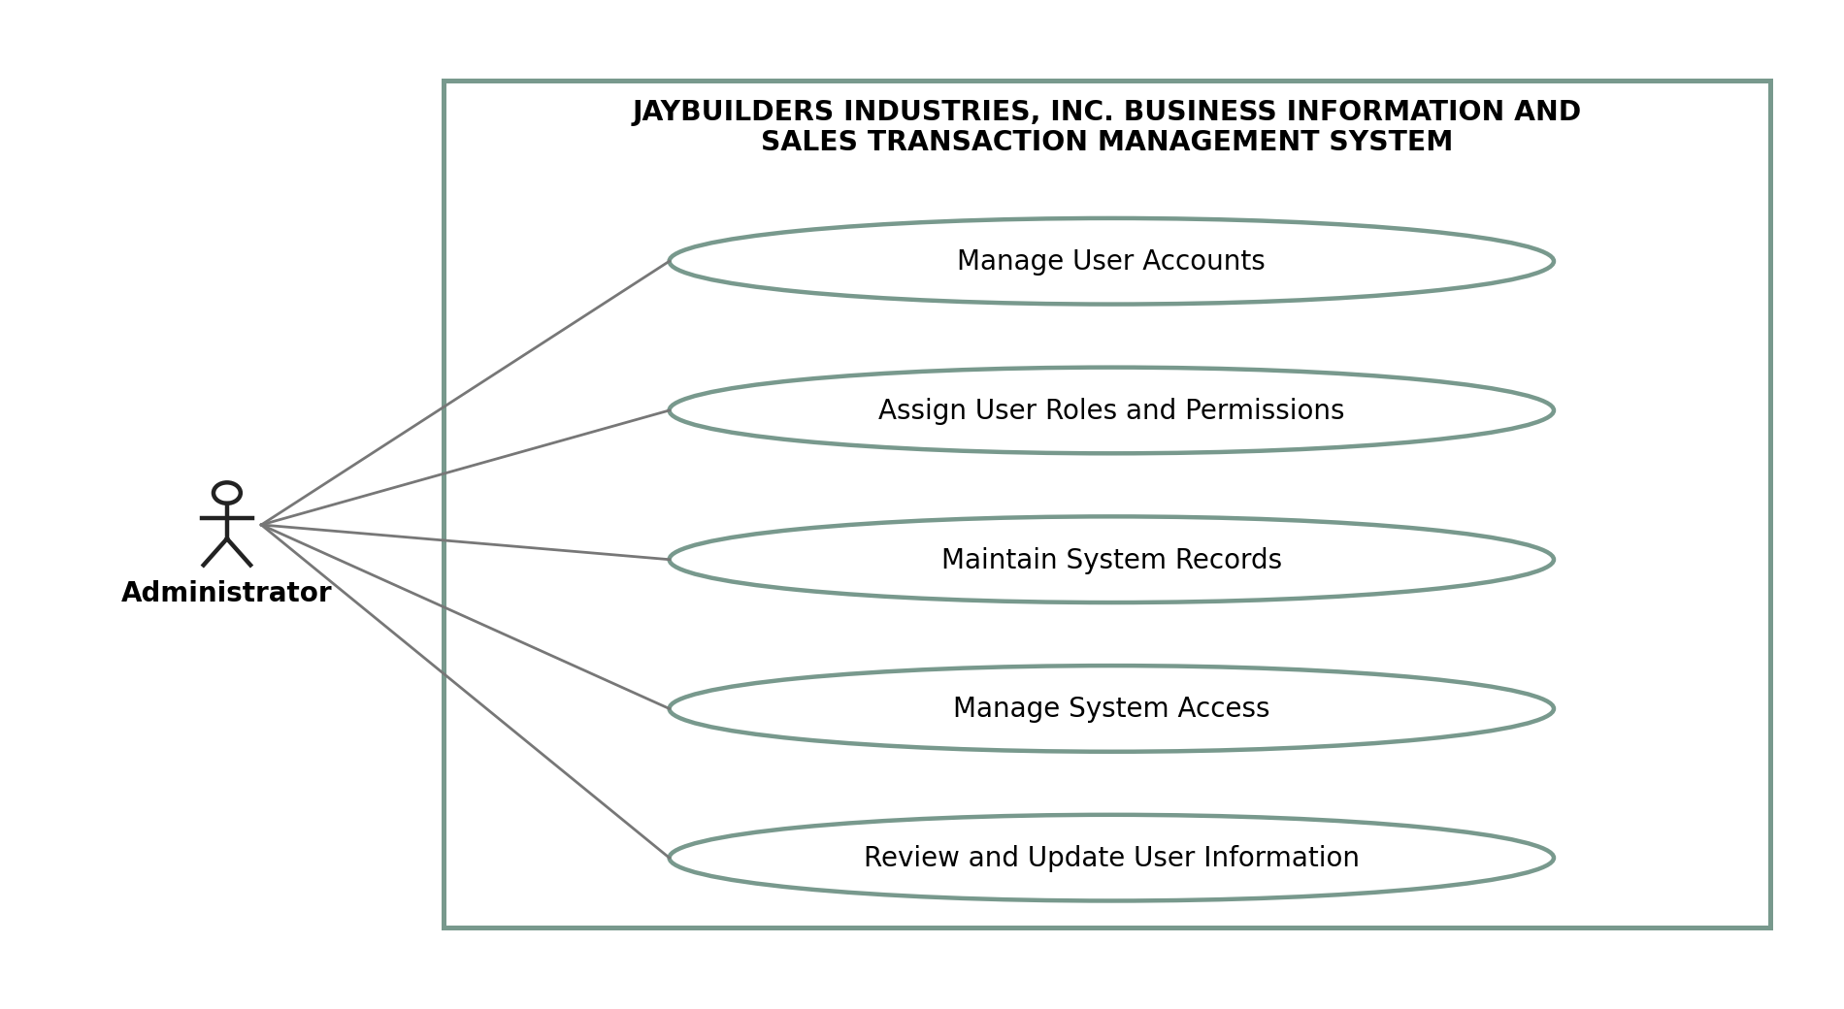

Appendix C – Entity-Relationship Diagram (ERD)
The proposed ERD presents the main database entities and their relationships. Customer records are linked to sales transactions, while each transaction may contain multiple transaction details. Product and service records are maintained separately to support standard and customized customer requirements.
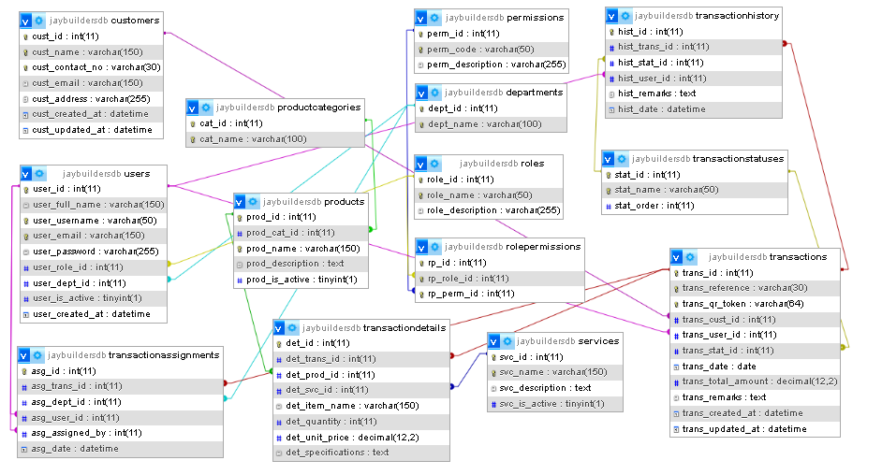
Figure C-1. Entity-relationship diagram showing the proposed database entities and their relationships.

Appendix D – System Architecture
The proposed system will use a three-tier web architecture consisting of a frontend, backend, and database, with reporting functions connected to the application logic. Users access the system through a web browser. The frontend displays forms, transaction records, dashboards, and reports. The backend validates requests, applies business rules, and checks user permissions before accessing the database. The database stores customer, product, service, sales transaction, user, and related records. The QR code feature uses a unique transaction reference to retrieve the corresponding record through the authorized application workflow.
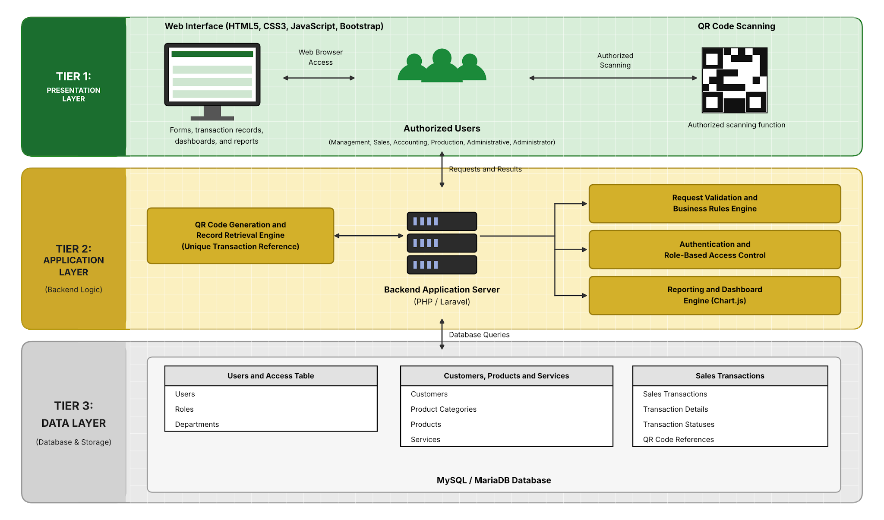
Figure D-1. System architecture showing how users, the web interface, application logic, QR code-based transaction tracking, reporting functions, and database interact.

Appendix E – UI/UX Prototypes
The following interfaces are proposed for the system. Screenshots or design prototypes will be attached after the interface design has been prepared and reviewed.

Figure E-1. Login Page
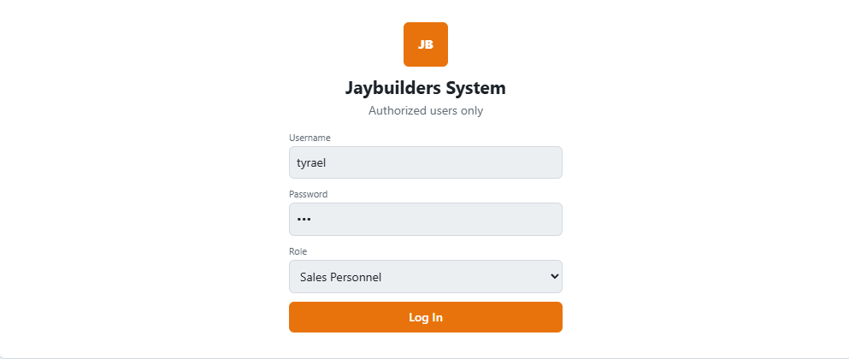
Figure E-1. The login page provides authorized users with access to the system using their assigned account credentials.

Figure E-2. Management Dashboard
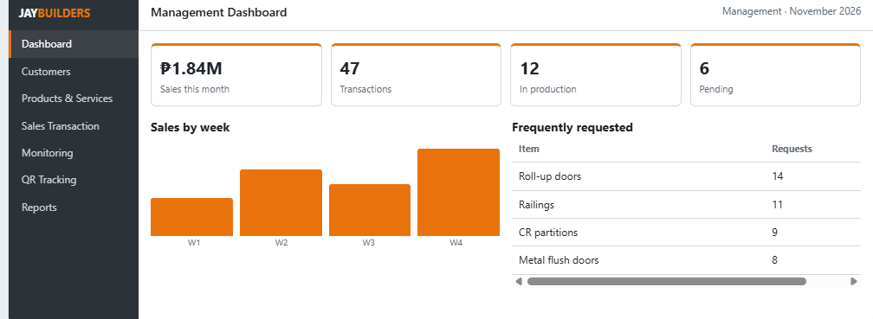
Figure E-2. The management dashboard presents summarized sales activity, transaction counts, and frequently requested products and services.

Figure E-3. Customer Management
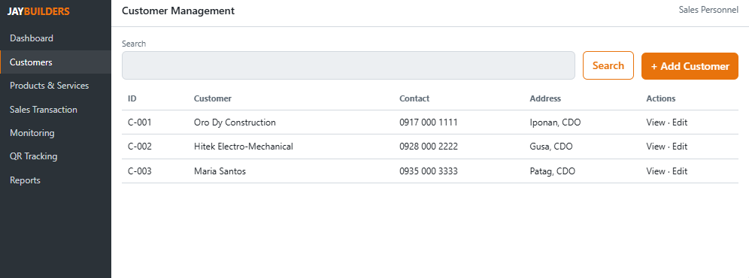
Figure E-3. The customer management page allows authorized personnel to add, update, search, and view customer records.

Figure E-4. Product and Service Management
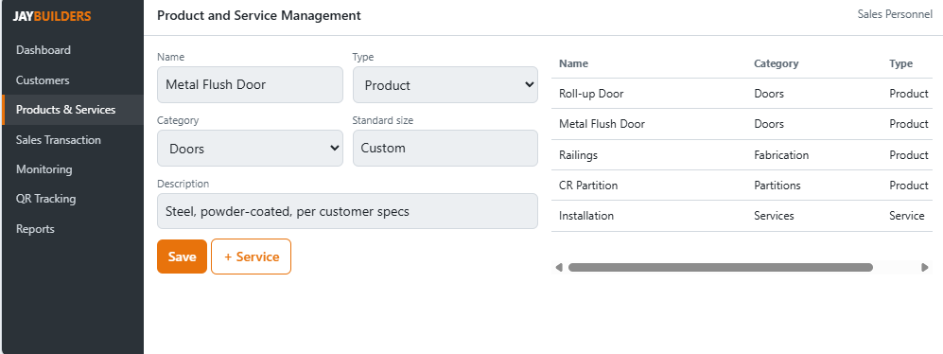
Figure E-4. The product and service management page maintains product categories, product descriptions, and service records used in customer transactions.

Figure E-5. Sales Transaction Page
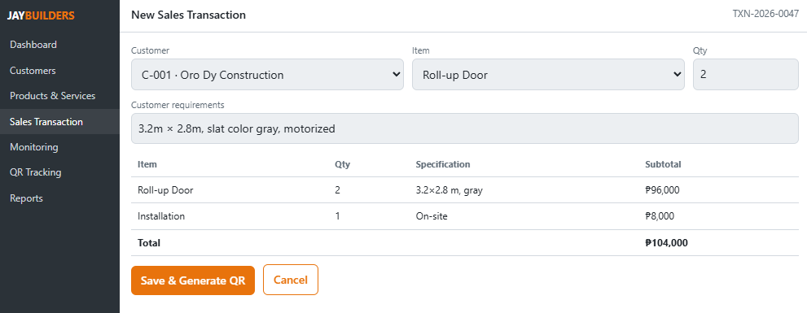
Figure E-5. The sales transaction page allows sales personnel to record customer requirements and the products or services included in a transaction.

Figure E-6. Transaction Monitoring Page
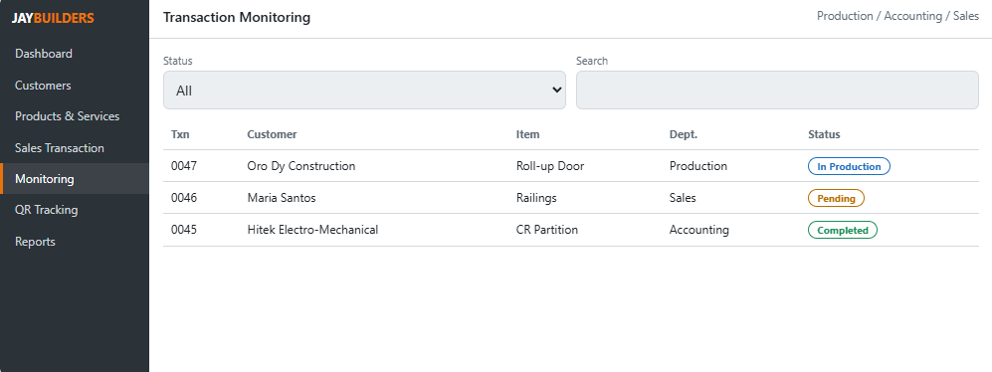
Figure E-6. The transaction monitoring page displays transaction details and status information to authorized personnel from relevant departments.

Figure E-7. QR Code Transaction Tracking Page
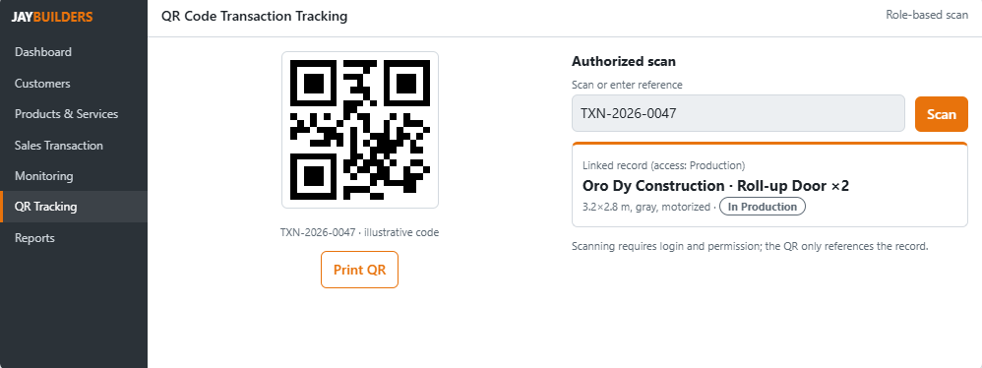
Figure E-7. The QR code page displays or generates a transaction-specific QR code and provides an authorized scanning function for retrieving the linked transaction record.

Figure E-8. Reports and Analytics Page
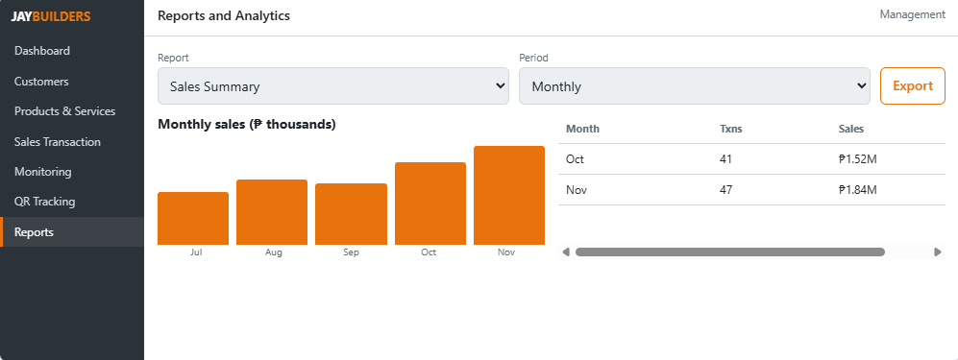
Figure E-8. The reports and analytics page presents periodic sales summaries and relevant business reports based on available transaction data.

Appendix F – Testing Instruments (For Later Phases)

F.1 System Usability Scale (SUS) Questionnaire
Instructions: After using the developed system, select the response that best represents your experience with each statement.
Scale:
1 – Strongly Disagree
2 – Disagree
3 – Neutral
4 – Agree
5 – Strongly Agree
- I think I would like to use this system frequently.
- I found the system easy to use.
- I felt comfortable using the different features of the system.
- I think the system’s functions are properly connected.
- I found the QR code transaction tracking feature easy to understand.
- I think the system makes customer and sales transaction information easier to manage.
- I would learn to use this system quickly.
- I felt confident while using the system.
- I think the system helps reduce reliance on separate manual records and spreadsheets.
- I would recommend this system for managing business information and sales transactions.

F.2 Sample Test Cases – QR Code and Sales Transaction Tracking
Test Case ID | Description | Input | Expected Output | Pass / Fail
TC-QR-01 | Generate a QR code for a saved transaction | Saved sales transaction | A unique QR code or QR code reference is generated and linked to the correct transaction
TC-QR-02 | Scan a valid transaction QR code | Valid transaction QR code and authorized account | The corresponding transaction record is displayed
TC-QR-03 | Scan an invalid QR code | Invalid or unrecognized QR code | The system rejects the code and displays an appropriate message
TC-QR-04 | Scan a QR code without permission | Valid transaction QR code and unauthorized account | The system denies access to restricted transaction information
TC-QR-05 | Scan a QR code for a transaction that does not exist | QR code containing an unknown transaction reference | The system reports that the transaction record cannot be found
TC-QR-06 | Retrieve a transaction after its status is updated | Valid QR code for an updated transaction | The system displays the latest authorized transaction information
TC-QR-07 | Generate QR codes for different transactions | Two or more saved sales transactions | Each transaction has a distinct QR code reference linked to its own record
TC-QR-08 | Scan the same QR code repeatedly | One valid transaction QR code scanned more than once | The same linked transaction is retrieved without creating duplicate transactions

F.3 Sample Test Cases – Customer, Product, and Service Management
Test Case ID | Description | Input | Expected Output | Pass / Fail
TC-DATA-01 | Add a new customer | Valid customer details | The customer record is saved and appears in the customer list
TC-DATA-02 | Update customer information | Existing customer record and revised details | The customer record is updated correctly
TC-DATA-03 | Search for a customer | Customer name or available search detail | Matching customer records are displayed
TC-DATA-04 | Add a product | Valid product details and category | The product record is saved and displayed
TC-DATA-05 | Add a service | Valid service details | The service record is saved and displayed
TC-DATA-06 | Submit incomplete required information | Customer, product, or service form with required fields missing | The system identifies required fields and prevents invalid submission

F.4 Sample Test Cases – User and System Functions
Test Case ID | Description | Input | Expected Output | Pass / Fail
TC-SYS-01 | Login with a valid account | Correct username and password | The user successfully enters the system
TC-SYS-02 | Login with an invalid account | Incorrect username or password | The system rejects the login and displays an error message
TC-SYS-03 | Access a restricted module | User account without permission for the selected module | The system denies access to the restricted module
TC-SYS-04 | Create a sales transaction | Valid customer, transaction details, and selected products or services | The transaction and its details are saved correctly
TC-SYS-05 | Update transaction status | Existing transaction and permitted status update | The new status is saved and displayed to authorized users
TC-SYS-06 | Generate a sales report | Selected reporting period and available transaction records | The system displays a report based on matching transaction records
TC-SYS-07 | View dashboard summary | User with dashboard permission | The dashboard displays the information allowed for the user’s role
TC-SYS-08 | Manage user account | Valid user information and assigned role | The administrator can create or update the user account and assigned access

F.5 Sample Test Cases – Reliability
Test Case ID | Description | Input | Expected Output | Pass / Fail
TC-REL-01 | Retrieve the same transaction repeatedly | Valid transaction QR code scanned repeatedly | The same transaction information is retrieved consistently
TC-REL-02 | Check saved transaction records after logging out | Saved transaction followed by logout and login | The saved transaction remains available and unchanged
TC-REL-03 | Process multiple sales transactions in one session | Several valid customer transactions | Each transaction and its details are recorded correctly without unintended duplication
TC-REL-04 | Access the system using different supported browsers | Same authorized account on supported browsers | The system provides consistent access to its supported functions and records
TC-REL-05 | Generate a report from saved transactions more than once | Same reporting period and unchanged transaction data | The system produces consistent report results

